**Efficacy of Social Distancing During COVID-19**

* **A Non-Pharmaceutical Measures**

Amruta Deshpande & Harika Penjerla

Kent State University

**ABSTRACT**

In the absence of cure for COVID-19, social distancing is the crucial non-pharmaceutical measure to slow down the spread of the disease thereby delaying epidemic peak, to relieve pressure on the healthcare system (CDC - Social Distancing 2020). Social distancing during Influenza pandemic was proven very effective based on supporting evidence obtained largely from observational and simulation studies (CDC - Emerging Infectious Diseases 2020). This paper aims to provide information about social Distancing, scenarios to implement and technologies used, mathematical and statistical based approaches.

Keywords: COVID-19, Machine Learning, Difference-In-Difference (DID), Pandemic, Social Distancing, Susceptible-infected-recovered (SIR), Technologies.

**INTRODUCTION**

Globally, there are more than 66.3M confirmed cases of COVID-19 (Coronavirus 2019), including 1.52M deaths and over 42.5M recovered cases in approximately 215 countries as of 5th December 2020 (COVID-19 Pandemic by Country & Territory 2020)[14]. COVID-19 is not the same as regular coronaviruses commonly transmitted among humans causing mild illness like common cold to severe diseases like Severe acute respiratory syndrome (SARS) and Middle East Respiratory Syndrome (MERS). Coronavirus belong to the Coronaviridae family in the Nidovirales order. The virus has crown-like spikes on the outer surface of the virus; thus, it was named as coronavirus (Adnan S 2020). COVID-19 (Coronavirus Disease 2019) is an infectious disease caused by severe acute respiratory syndrome coronavirus 2 (SARS-CoV-2). COVID-19 was first identified in Wuhan, China in December 2019. This outbreak was initiated from Hunan seafood market, where frequently live animals such as bats, rabbits, snakes, etc. are sold. It was found that the genome sequence of SARS-CoV-2 is 96.2% identical to a bat CoV RaTG132. By the end of 2019, Chinese government informed WHO about several pneumonia cases with unknown etiology.  In March 2020, the World Health Organization declared COVID as a pandemic.

COVID19 spreads primarily by being in contact with an infected person, exposed to coughing, sneezing, respiratory droplets or aerosols. These aerosols are penetrated in the human lungs via mouth and nose (World Helath Organization - Coronavirus 2020). Most infected people will experience mild to moderate respiratory illness. But when it comes to the older people and those having pre-existing medical problems are experiencing serious illness.

The best approach to prevent or reduce the spread is to educate about the disease and precautions. To avoid transmission of COVID-19 there are few preventive measures recommended by the WHO, which includes hand washing, covering mouth while coughing, social distancing, wearing a face mask in public, disinfecting surfaces, increasing ventilation and air filtration indoors. Social distancing not only reduces negative impact, but also provides time for pharmaceutical solution development (Nguyen T 2020).

**SOCIAL DISTANCING**

Social distancing means keeping physical distance between yourself and other people who are not from the same household. Social distancing can be done in two ways; Individual and Public. Individual measures include quarantine and isolation. Whereas, public measures include closures of schools and office buildings, cancel gathering and suspension of public places [ (CDC - SARS 2004), (Nguyen T 2020)] It reduces the probability of the disease being transmitted from an infected person to a healthy one. And thus, if implemented properly during a pandemic, social distancing measure can play a key role in reducing the infection rate and delay the disease peak. Thereby reducing the burden on the healthcare systems and lowering death rates (Nguyen T 2020). Social distancing measures have played a role in mitigating previous pandemics, including the 1918–19 pandemic (Howard M 2007) . Although Social Distancing measures can cause negative impacts in economy, individual freedom and mental illness but still plays a crucial role in reducing severity of the pandemic (Joel K 2009). The main parameter for Social Distancing measures selection is basic reproduction number R0 which represents average how many people a case will infect during its entire infectious period.

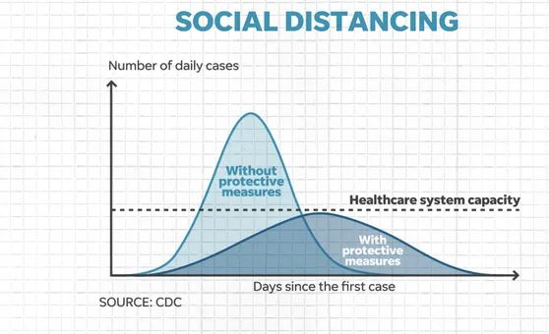

**Figure 1**: Effect of Social Distancing (Marc L 2020)

**SCENARIOS**

Some of the practical implementation of Social Distancing in real life scenarios presented in survey paper (Nguyen T 2020).

*Maintaining physical distance*:

Various AI and positioning technologies can be useful in maintaining distance between people. If people are not maintaining 6 feet distance between themselves, they will be alerted.

Example: Amazon putting AI cameras in warehouses (Eadicicco 2020).

*Real-time Monitoring:*

Monitoring people in real time public places to gather data like number of people inside buildings, contacts, crowds etc. to maintain social distancing. Based on this scenario we can limit access to building, avoid crowds.

Example: V-app which helps to monitor people in stores and social distancing measures by providing dashboard (VAPP for Social Distancing 2020).

*Information System:*

Technologies like Bluetooth, thermal, GPS and Ultra-wide brand can be employed to collect movement data of infected people and contact that these individuals made. Based on this scenario one can take self-isolation and stop the spread of disease.

*Scheduling:*

Scheduling techniques can be used to increase the efficiency of workforce and home healthcare services resulting in decreased number of employees and patients, respectively.

Example: Wi-fi, RFID, Zigbee technologies for building scheduling.

*Artificial Intelligence:*

AI helps to predict the future trends and movement of infected individuals.

**MATHEMATICAL MODELLING OF INFECTIOUS DISEASE**

The **SIR model** is one of the simplest compartmental models, and many models are derivatives of this basic form. The model consists of three compartments:

S: The number of susceptible individuals. When a susceptible and an infectious individual come into "infectious contact", the susceptible individual contracts the disease and transitions to the infectious compartment.

I: The number of infectious individuals. These are individuals who have been infected and are capable of infecting susceptible individuals.

R: The number of removed (and immune) or deceased individuals. These are individuals who have been infected and have either recovered from the disease and entered the removed compartment or died. It is assumed that the number of deaths is negligible with respect to the total population. This compartment may also be called "recovered" or "resistant".

This model is reasonably predictive for infectious diseases that are transmitted from human to human (Compartmental Models n.d.).

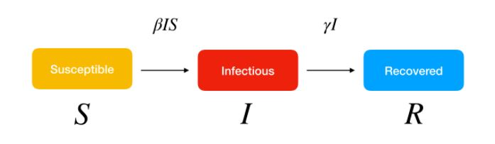

**Figure 2:** SIR Model

SIR describes number of people in each compartment with ordinary differential equation.

β is parameter controlling how much the disease can be transmitted through exposure. It is determined by the chance of contact and probability of disease transmission. Γ is parameter expressing how much the disease can be recovered in specific period. Once the people are healed, they get immunity. There are no chances for them to go back susceptible again (Sasaki 2020). An mathematical approach for role of Social distancing policies analyzing transmission rate by using GPS mobility data from google and apple as well as disease statistics from European CDC in 26 countries over 5 weeks explains ~47% of the variation in transmission rates. Provided specific insights for public health policy makers regarding locations that should be given priority for enforcing social distancing measures (Dursun D 2020). This study is limited to small sample size, unavailability of granular mobility and COVID-19 data.

**STATISTICAL TECHNIQUE**

Difference in Differences (DID) approach mainly used in econometrics and quantitative research in social sciences that attempts using observational data by studying differential effect of treatment group versus control group. DID is typically used to estimate the effect of a specific intervention or treatment (such as a passage of law, enactment of policy, or large-scale program implementation) by comparing the changes in outcomes over time between a population that is enrolled in a program (the intervention group) and a population that is not the control group (Columbia Public Health - Difference-in-Difference Estimation 2007). Below is the graphical explanation of DID estimation. If the composition of groups pre- and post-change are not in the table, then this model cannot be used, and this limits the application of DID. It highly depends on assumption that treatment and control unit’s outcome follow parallel trends in pretreatment.

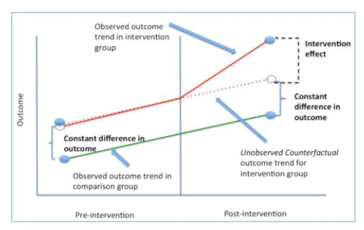

**Figure3:** DID Estimation.

Synthetic Control Method (SCM) is a statistical method used to evaluate the effect of an intervention in comparative case studies. SCM overcomes the parallel trend assumption which involves the construction of weighted combination of groups used as control to which treatment group is compared [12] (Synthetic Control Method 2015). It uses a machine learning approach. One of the most sophisticated approach is generalized synthetic control method that combines SCM with Interactive Fixed Effect model (model time-varying unit specific factors) [13] (Syed M 2020). This paper [13] (Syed M 2020), deduce that the US states that adopted social distancing early than rest are associated with the lower COVID-19 rate by 192% (ATT-1.92).

**CONCLUSION**

Social distancing has been a crucial measure to slow down the spread of contagious diseases such as previous pandemic - Influenza, now - COVID-19. In this paper with a focus on overall introduction to ongoing COVID-19 pandemic, necessary preventive measures mainly about Social Distancing. Few scenarios of implementing Social Distancing with different technologies. It is also given brief introduction to general mathematical and statistical modeling. There are open issues of Social Distancing implementation such as security and privacy concerns, increase in healthcare appointments, home health- care services and online services. There are many potential solutions which needs to be addressed.

**ACKNOWLEDGEMENT**

We would like to express our sincere gratitude to Dr. Murali Shanker for extraordinary support and encouragement to do this research paperwork. We also want to mention his patience and helping us in every step of the study.

# **REFERENCES**

Adnan S, Rabeea S. 2020. "COVID-19 Infection: Origin, transmission and characteristics." *ScienceDirect* 91-98.

2020. *CDC - Emerging Infectious Diseases.* May 5. https://wwwnc.cdc.gov/eid/article/26/5/19-0995_article.

2004. *CDC - SARS.* https://www.cdc.gov/sars/guidance/d-quarantine/app1.html.

2020. *CDC - Social Distancing.* March 16. https://www.cdc.gov/coronavirus/2019-ncov/prevent-getting-sick/social-distancing.html.

2007. *Columbia Public Health - Difference-in-Difference Estimation.*

n.d. "Compartmental Models." *Wikipedia.* https://en.wikipedia.org/wiki/Compartmental_models_in_epidemiology.

2020. *COVID-19 Pandemic by Country & Territory.* https://en.wikipedia.org/wiki/COVID-19_pandemic_by_country_and_territory.

Dursun D, Enes E. 2020. "No Place Like Home: Cross-National Data Analysis of the Efficacy." *JMIR.*

Eadicicco, Lisa. 2020. "Amazon putting AI cameras in Warehouses." *Business Insider.* June 16. https://www.businessinsider.com/amazon-warehouses-ai-cameras-make-sure-employees-social-distance-2020-6.

Howard M, Harvey B. 2007. "Nonpharmaceutical interventions implemented by US cities during influenza pandemic." *National Library of Medicine.* https://pubmed.ncbi.nlm.nih.gov/17684187/, August 2007.

Joel K, George J. 2009. "Simulation suggests that rapid activation of social distancing can arrest epidemic development due to a novel strain of influenza." *BMC Public Health.*

Marc L, Joseph A. 2020. *Coronovirus Reality Check.* March 16. https://www.usatoday.com/story/opinion/2020/03/16/coronavirus-social-distancing-myths-realities-column/5053696002/.

Nguyen T, Yuris M, Bui M. 2020. "Enabling and Emerging Technologies for Social Distancing." *arXiv.*

Sasaki, Kai. 2020. "COVID-19 dynamics with SIR model." https://www.lewuathe.com/covid-19-dynamics-with-sir-model.html.

Syed M, Nazmus Sakib. 2020. "Stay Home Save Lives: A Machine Learning Approach to Causal Inference to Evaluate Impact of Social Distancing in the US." *Research Square.*

2015. *Synthetic Control Method.* https://en.wikipedia.org/wiki/Synthetic_control_method.

2020. "VAPP for Social Distancing." https://www.v-app.io/social-distancing-monitoring/.

2020. *World Helath Organization - Coronavirus.* https://www.who.int/health-topics/coronavirus.